**Decision Tree of Titanic project**

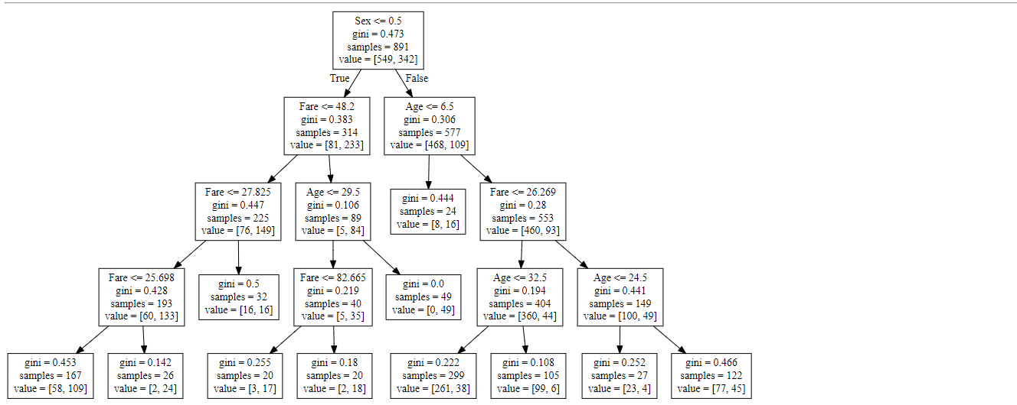

**From above we can conclude the rules as follows:**

1. If Sex is Female and Fare <= 25.6, then % of persons survived = 109/167 = 0.65
2. If Sex is Female and 25.6 < Fare <= 27.8, then the person is survived.
3. If Sex is Female and 27.8 < Fare <= 48.2, then % of persons survived = 16/32 = 0.50
4. If Sex is Female and 48.2 < Fare <= 82.6 and Age < 29.5, then % of persons survived= 17/20 = 0.85
5. If Sex is Female and Fare > 82.6 and Age <= 29.5, then % of persons survived= 18/20 = 0.90
6. If Sex is Female and Fare > 48.2 and Age > 29.5, then person is survived
7. If Sex is Male and Age <= 6.5 , then % of persons survived= 16/24 = 0.66
8. If Sex is Male and 6.5 < Age <= 32.5 and Fare <=26.2 , then % of persons survived= 38/299 = 0.12
9. If Sex is Male and Age > 32.5 and Fare <=26.2 , then % of persons survived= 6/105 = 0.05
10. If Sex is Male and 6.5 < Age <= 24.5 and Fare >26.2 , then % of persons survived= 4/27 = 0.14
11. If Sex is Male and Age > 24.5 and Fare <=26.2 , then % of persons survived= 45/122 = 0.36